**Project UnMuted**

**Team – Clair_AI**

**School** – Delhi Public School Bangalore North Cambridge

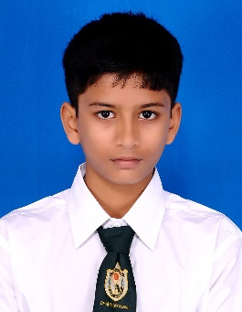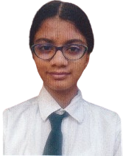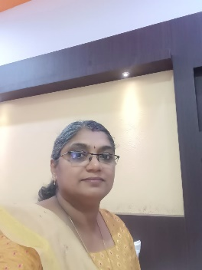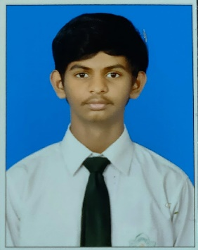

**Nishanth Alampally**Team Leader  
Lead Developer and Training

**Ms. Lekshmi P. Nair**  
Mentor

**Sai Juhith Paleti**   
Research and Training

**Kshipra Kashyap**   
Research and Training

**Project Overview**

**UnMuted** is an **Artificial** **Intelligence** **(AI)** model that enables you to translate **sign** **language** in real time. With UnMuted, you don’t have to worry about ability barriers – not when you can use it anywhere, anytime and anyplace.

**The Problem**

Over **72** **million** people worldwide primarily communicate using sign language. However, not everyone in the world knows sign language, making communication difficult. To overcome this problem, our team has harnessed the power of AI to develop an application that recognizes and translates sign language real-time.

**Development**

Using **Google’s** **Mediapipe** package and **Tensorflow’s** **Sequential** model, our application recognizes **key-points** in the signer’s hands and uses them to identify the sign and display an accurate translation to the user.

**Training**

During manual training, each sign is recorded 20 times and the key-points are stored as **numpy** **arrays**. These are then fed to the Sequential model and trained until the desired accuracy is met.

**Implementation**

Being a software application, the model can be used on phones and downloaded from app stores. Integration with platforms like Zoom and Google Meet allows for enhanced online communication. Additionally, the software can be implemented in devices with a growing user base like the Ray Ban Meta Smart Glasses or the Apple Vision Pro. UnMuted shines in **real-time** interactions, such as those that take place in banks and hospitals.

**Future Road Map**

Google’s newer version of Mediapipe (set to release this year) can help us develop UnMuted further. Using available databases like the **ASLLVD** and **ASL-LEX**, we can increase the number of signs, words and sign languages for a fully-functioning first version for public release as a free app.